Phase 3 – Project Design
1. Project Title
Import Data using Transform Maps (Spreadsheet)

2. Introduction
The Project Design phase describes the structure and workflow of the proposed ServiceNow solution. The system is designed to import employee information from a spreadsheet, temporarily store the data in an Import Set table, transform the data using a Transform Map, and store the processed records in the Employee Test table.
The design also includes Coalesce functionality for identifying existing employee records, followed by reports and an employee analytics dashboard.

3. System Architecture
The overall system is designed
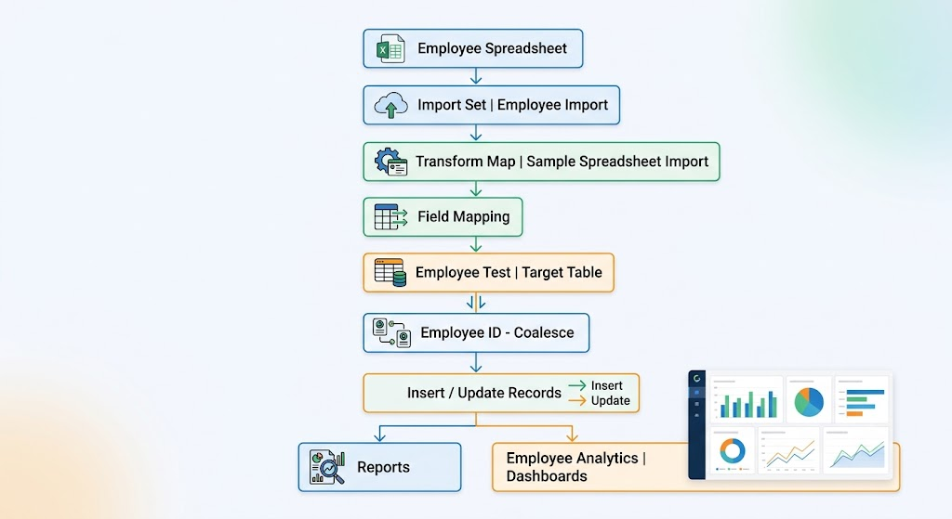
The project guide describes the spreadsheet → Import Set → Transform Map → target table workflow and subsequent validation/reporting stages.

4. Database/Table Design
The project contains two main tables involved in the import process.
4.1 Employee Import Table
The Employee Import table acts as the staging table for data loaded from the spreadsheet.
Table Name:
u_employee_import
The project guide specifies Employee Import as the Import Set table.
4.2 Employee Test Table
The Employee Test table is the target table where the transformed employee information is stored.
Table Name:
u_employee_test
The table contains the following fields:
Field | Data Type | Purpose
Employee ID | String | Identifies the employee
Employee Name | String | Stores employee name
Email | String | Stores employee email
Department | String | Stores employee department
Location | String | Stores employee location

Figure 1: Table Design
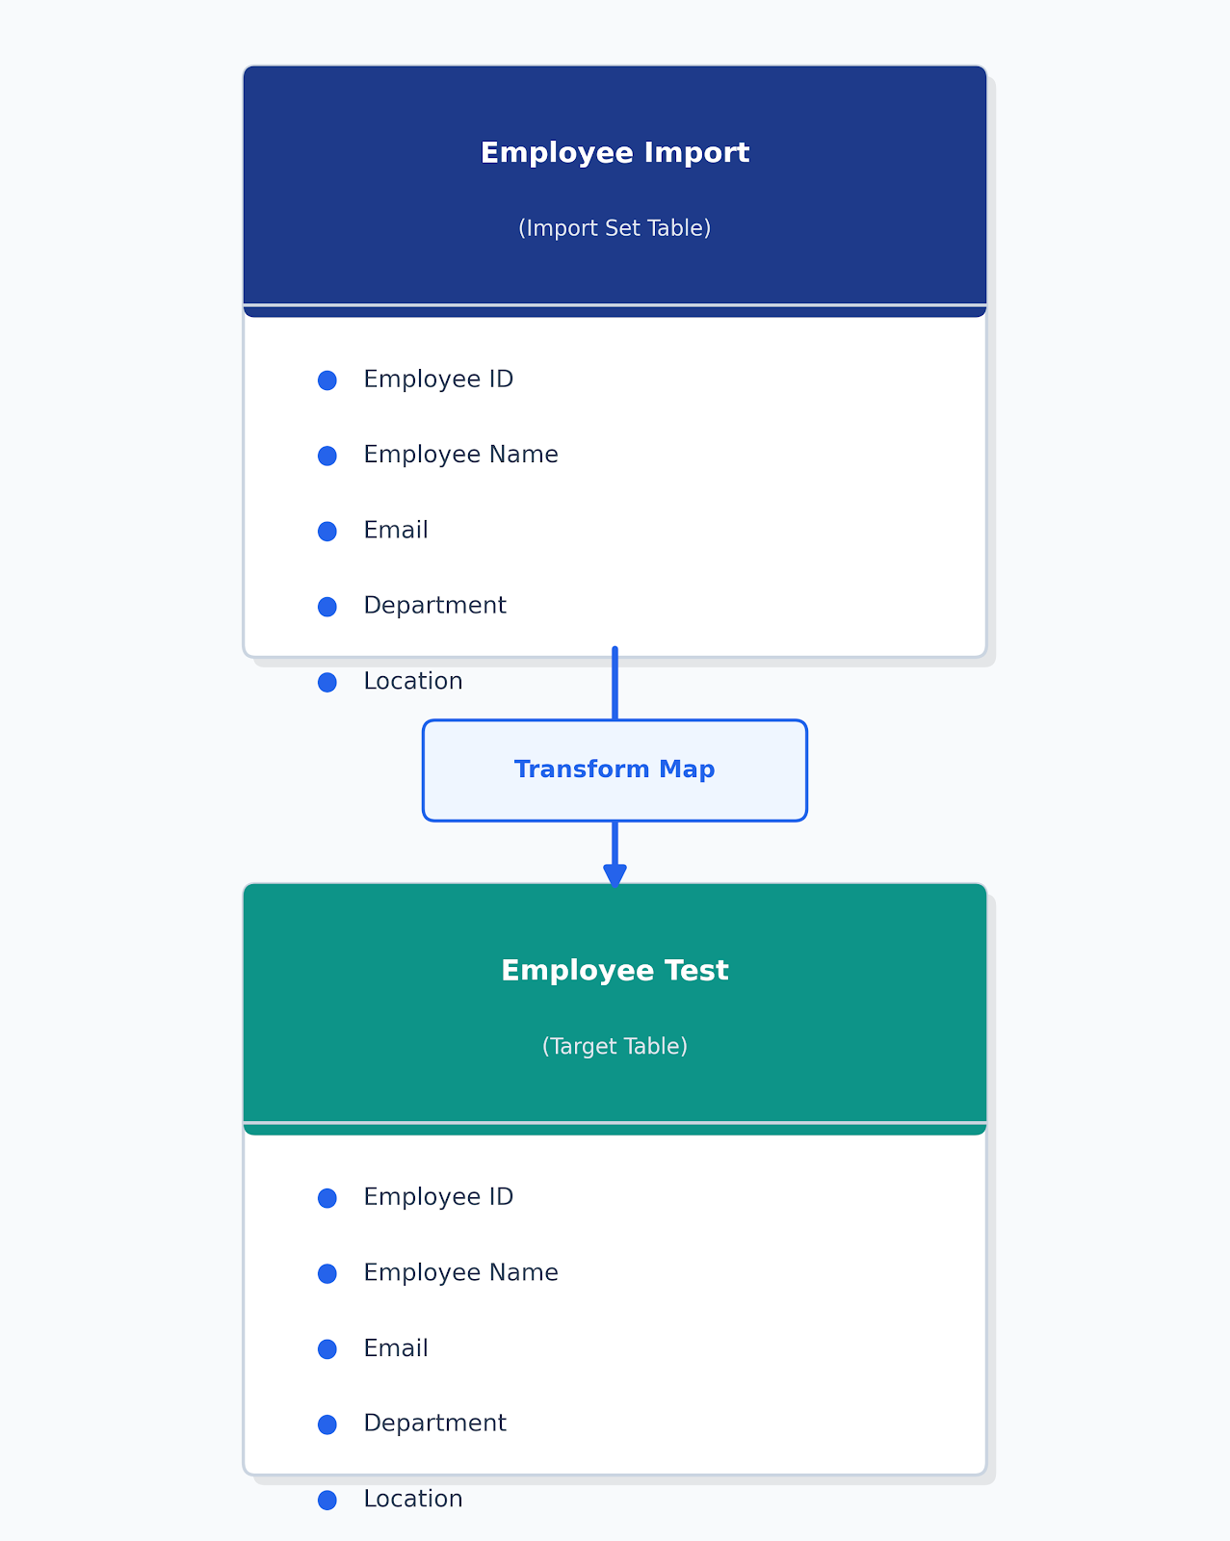

5. Transform Map Design
A Transform Map is used to transfer data from the Employee Import table to the Employee Test table.
Transform Map Details
Property | Value
Transform Map Name | Sample Spreadsheet Import
Source Table | Employee Import
Target Table | Employee Test

The project guide specifies this Transform Map configuration and the use of field mapping between source and target tables.

6. Field Mapping Design
The source fields from the Employee Import table are mapped to their corresponding fields in the Employee Test table.
Source Field | Target Field
Employee ID | Employee ID
Employee Name | Employee Name
Email | Email
Department | Department
Location | Location

This mapping ensures that the imported spreadsheet information is stored in the appropriate fields of the target table.

7. Coalesce Design
The project uses Employee ID as the Coalesce field.
Coalesce Configuration
SourceField:EmployeeID
TargetField:EmployeeID
Coalesce: True
Employee ID is used because it uniquely identifies an employee. When the same Employee ID already exists, the corresponding record can be updated instead of creating another record. When the Employee ID is new, a new employee record can be inserted.

Coalesce Flow
Employee ID
|
+-------+-------+
| |
Existing New
Record Record
| |
↓ ↓
UPDATE INSERT

8. Import Process Design
The import process is designed in the following sequence:
Step 1 – Prepare Spreadsheet
Employee information is prepared in spreadsheet format.
Step 2 – Load Data
The spreadsheet is loaded into the Employee Import Import Set table.
Step 3 – Select Transform Map
The Sample Spreadsheet Import Transform Map is selected.
Step 4 – Transform Data
The source fields are mapped to the corresponding Employee Test fields.
Step 5 – Apply Coalesce
Employee ID is used to determine whether a record already exists.
Step 6 – Store Records
- Existing employees → Updated
- New employees → Inserted
Step 7 – Validate
The Employee Test table is checked to verify the imported records.
The project guide specifies running the Transform and checking the resulting records in the Employee Test table.

9. Report Design
Three reports are included in the project.
9.1 Employees by Department
ReportType:PieChart
SourceTable:EmployeeTest
GroupBy:Department
Aggregation: Count
This report represents the number of employees in each department.

9.2 Employees by Location
ReportType:BarChart
SourceTable:EmployeeTest
GroupBy:Location
Aggregation: Count
This report represents employee distribution based on location.

9.3 Employee List Report
ReportType:List
Source Table: Employee Test
The report displays:
- Employee ID
- Employee Name
- Email
- Department
- Location
The project guide specifies these columns for the Employee List Report.

10. Dashboard Design
The project includes a dashboard named:
Employee Analytics Dashboards
The dashboard is designed to provide a centralized view of the employee information using the three created reports.
Dashboard Components
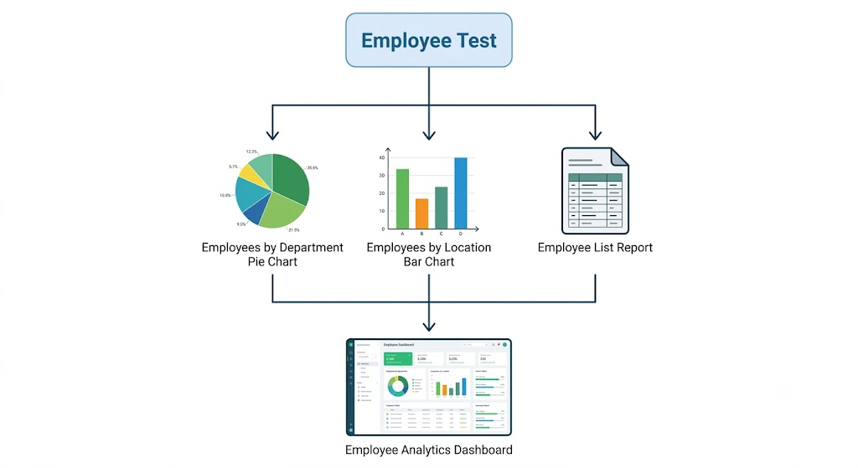

11. Complete Project Workflow
The complete design of the system can be represented as:
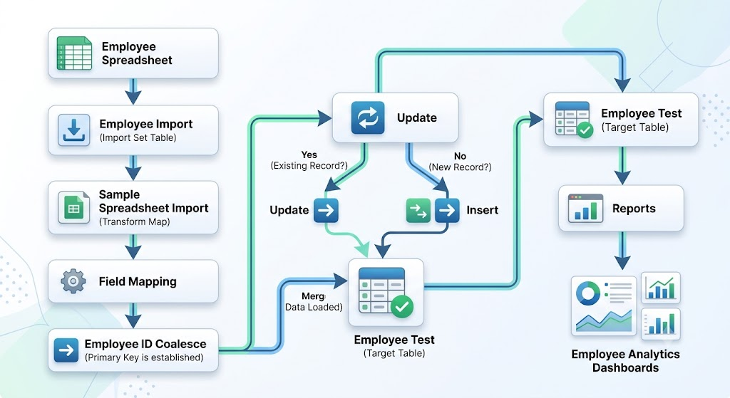

12. Design Summary
The project design provides a structured mechanism for importing and managing employee information in ServiceNow. The Import Set acts as the staging area, while the Transform Map controls the movement and mapping of data into the Employee Test table.
Employee ID is designed as the Coalesce field to support both updating existing employee records and inserting new records. The resulting employee data is then represented through department, location, and list reports and displayed through the Employee Analytics Dashboards.

